**REPORT ON THE REMOBILIZATION SURVEY FOR THE KOFKRO PROJECT**

**Author: Francis Adu Amankwah**

**Organization: AFES – GHANA**

**13th November 2024**

**INTRODUCTION**

The youth represent the most vibrant part of the New Juaben South Municipality (NJSM), hence there is the need to mainstream the challenges they face in their communities that acts as barriers to their participation in youth governance. Again, as they hold the promise of the future, we must explore avenues to help them address these challenges and engage them meaningfully in the decision-making process. This survey seeks to ascertain

* The participation of the youth in governance
* The demographics and social status of the youth in Koforidua
* The challenges they face in their communities
* The interests of the youth
* The avenues for youth development.

The survey covers the New Juaben South district across 34 electoral areas on youth aged 15 – 35. For the remobilization, there was a particular focus on marginalised groups such as Persons with Disabilities (PWDs), Ghetto, Street and Zongo youth.

**METHODOLOGY**

**Survey Design**

The survey consisted of 45 unique questions under the thematic areas of demographics, contact information, employment status, interest and needs, and participation in governance.

**Sampling Technique**

To address our aim of reaching marginalised groups (especially in the case of PWDs), we used the snowballing technique. At the end of the survey, we had 2932 respondents, of whom about 5% were PWDs.

**Data Collection Process**

The data collection was carried out by 30 enumerators from the AFES – Ghana group over a two weeks period in October 2024. It was collected using an online questionnaire.

**Data Analysis**

We employed univariate and multivariate analysis to ascertain the distribution of variables of interest such as education status, employment status, gender, age, participation in election, challenges and interest of the youth.

**RESULTS**

**Demographics**

In the analysis, we found that 37.2% of the respondents were within the age range of 21 – 25, 30.9% in 15 – 20, 21.7% between 26 – 30 and 10.2% in 31 – 35 with a gender distribution of 60.4% males and 39.6% females. About 9% of the respondents were married. We had that about 5% of the respondents had various disabilities. Regarding the educational background of the respondents, about 65% said they had attended school in the past, 30.8% are currently schooling whiles 3.8% had never attended school. Figure 1 shows the educational levels for the respondents who are currently schooling and those who attended in the past respectively.

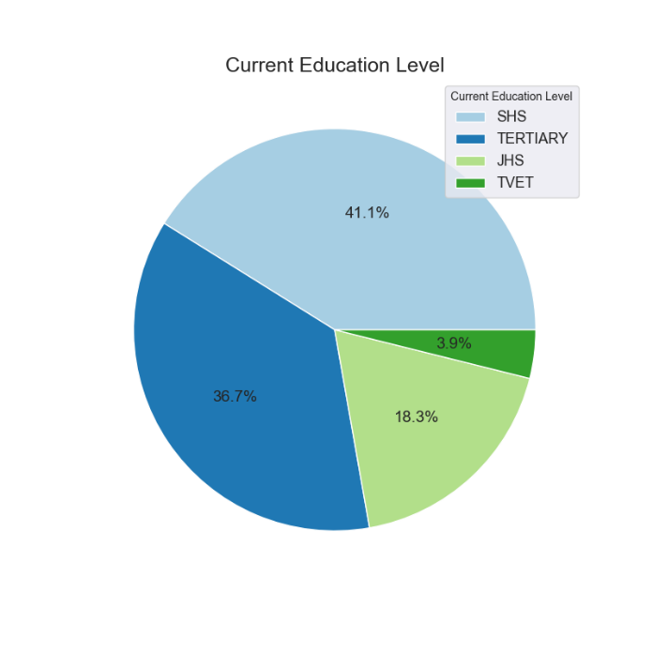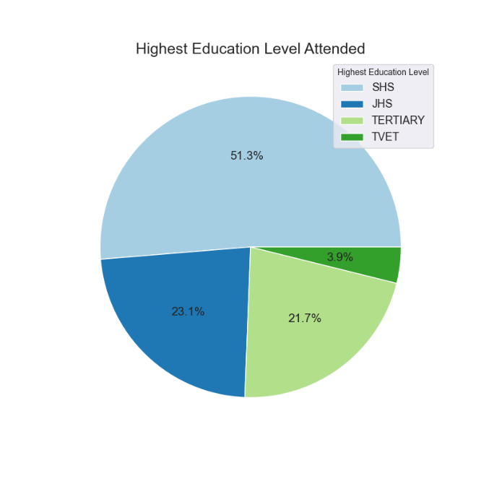

Figure 1: Respective educational level for respondents currently schooling and those who attended in the past

The distribution of the various types of disabilities the respondents had is shown in Figure 2. Of all persons with disabilities interviewed, the most dominant type of disability is physical disability followed by hearing impairment and visual impairment. As we can see from the graph, they are some individuals with more than one type of disability.

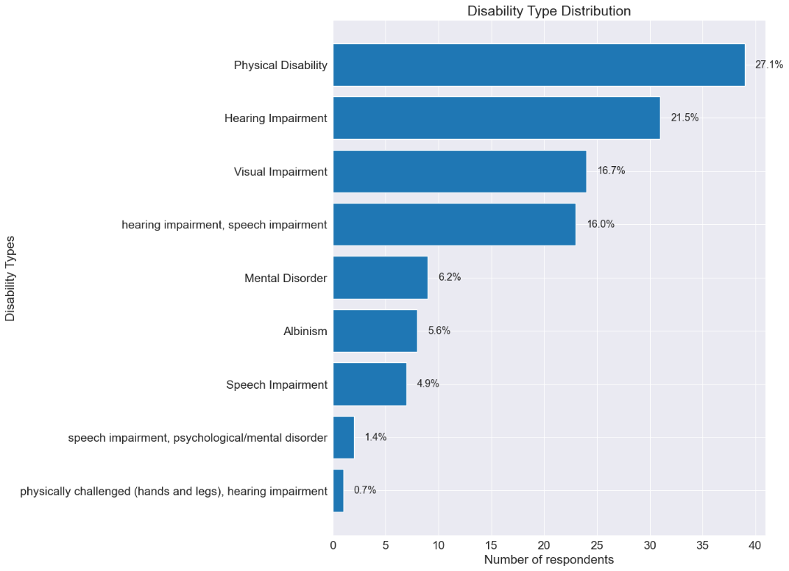

Figure 2: Types of disability

As mentioned earlier, the survey was conducted across all 34 electoral areas in NJSM. The distribution of the number of respondents in each electoral area is shown in Figure 3. As we can see, the *Nsukwaoso* electoral area appears to have the highest number of respondents.

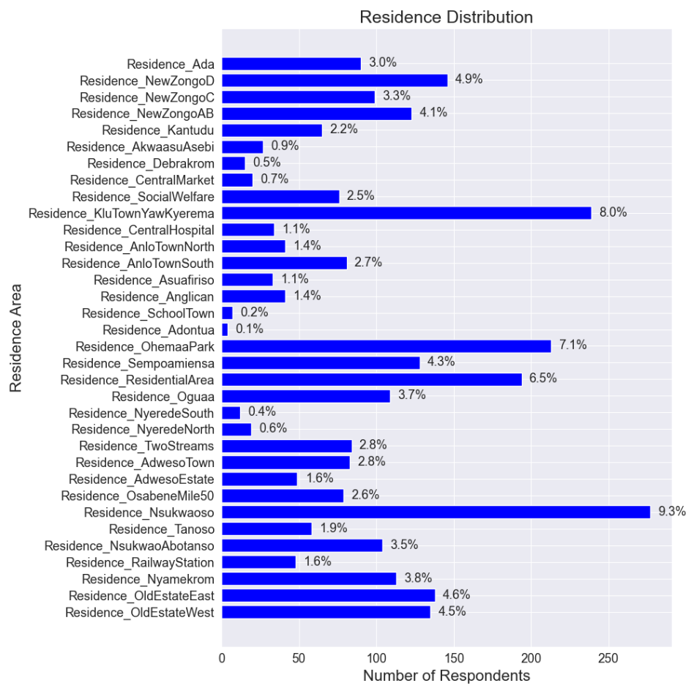

Figure 3: Percentage of respondents from each electoral area

To ascertain which respondents can be categorised as ghetto, street or Zongo youth, we made a distribution of the places they spend most of their time during the day and at night, which is shown in Figure 4.

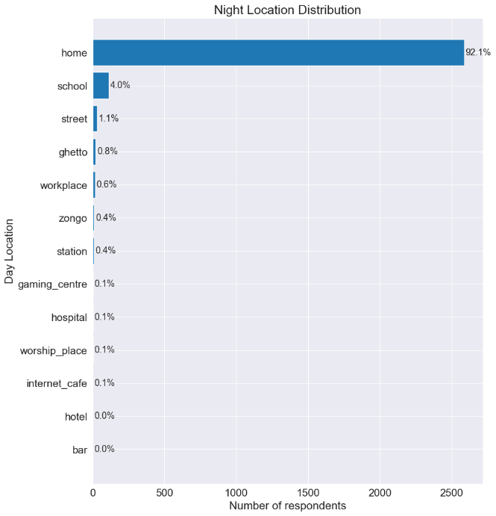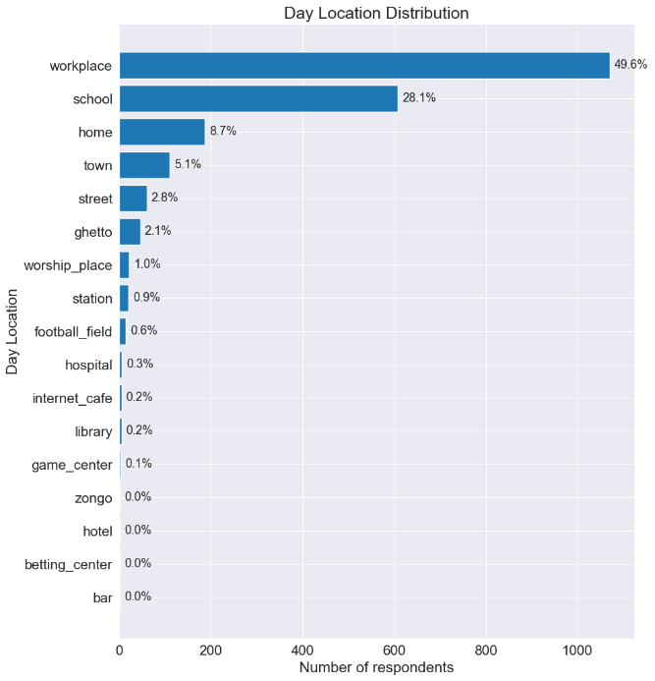

Figure 4: Location where most time is spent during the day and night

In the evenings, we have most of the respondents staying home (over 90%). To narrow it down to the marginalised groups we are interested in (street, ghetto and zongo youth), a special distribution was made separately for these locations.

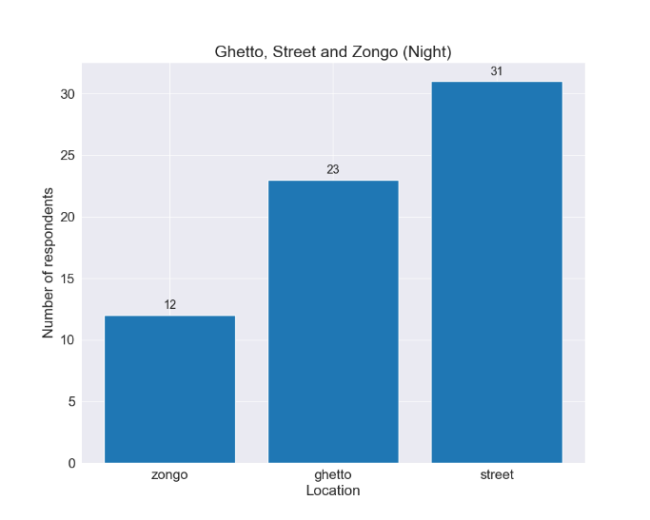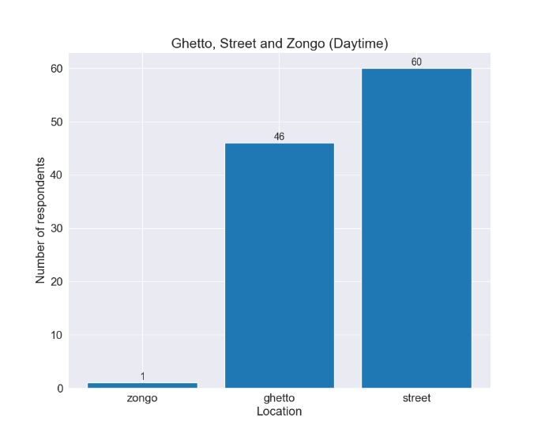

Figure 5: Distribution for respondents who spend most of their time in ghettos, zongo or on the street.

From Figure 5, we can see that we have more street youth than ghetto or zongo youth. Especially during the day, we have only one respondent who spends most of the time in Zongo.

**Employment Status**

Questions about the employment status of respondents helps to ascertain the social welfare and possibly hint on their wellbeing. Out of all the respondents, 60% were unemployed, 15.9% were employed and 24.2% were self-employed. This hints to the huge problem of unemployment facing the youth in the NJSM. Again, larger proportion of workers who are self-employed compared to those employed by others asserts to the entrepreneurial spirit of the youth. It stands to reason that provided with the resources and support, most of the youth might venture into entrepreneurship, thereby providing employments for themselves and others. Figure 6 gives a distribution of the various works the working proportion of the youth are engaged in. From Figure 6, it has been established that most of the youth are involved in sales and a significant number specialize in ventures where they offer services.

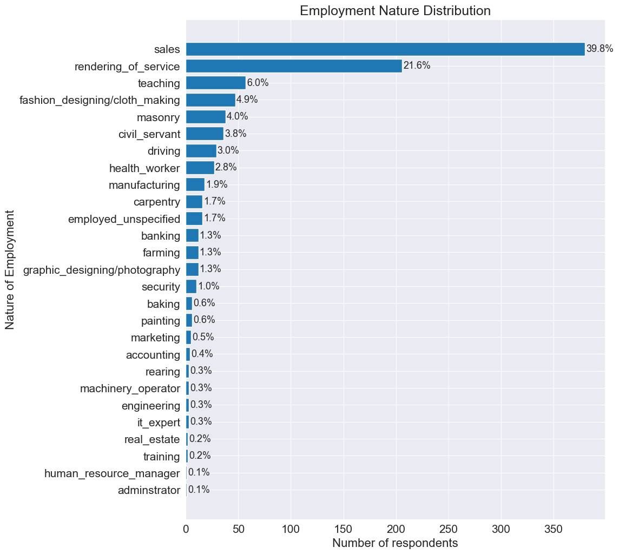

Figure : Nature of employment by the working population of the respondents.

**Access to Social Amenities**

About 90.5% of all respondents had access to basic social amenities. In the survey, the amenities considered were; water, electricity, hospitals, schools and toilet facilities. A significant proportion (about 7.6%) reported they do not have access to these social amenities. Figure 7 shows the percentage of respondents which had access to each of the amenities listed above.

We can establish that most of the residents in the NJSM have access to electricity compared to other amenities. Again, 89.2% of the respondents said they had the National Health Insurance Scheme (NHIS) card, which hinted on their access to healthcare. About 9.9% had no insurance card and 0.9% where no sure whether they had a health insurance card or not. This response could be associated with issues such as expired insurance cards.

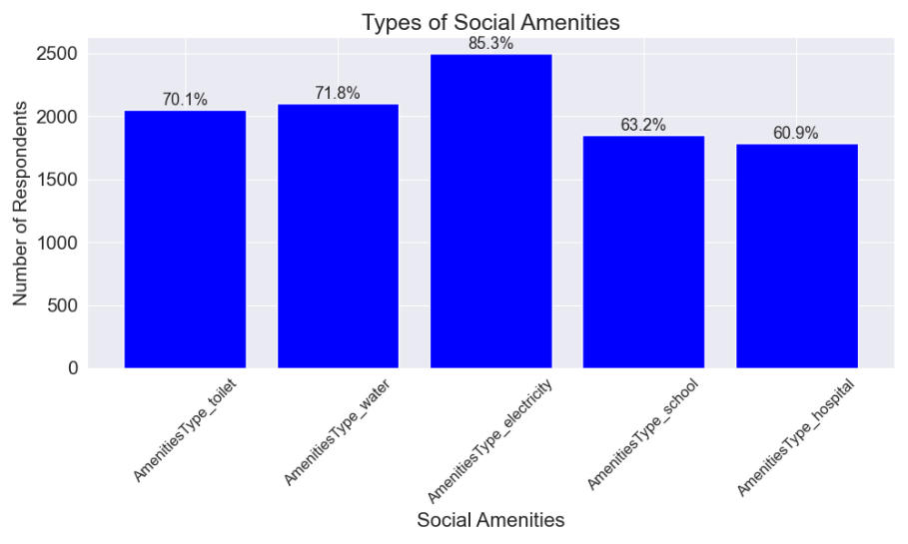

Figure : Access to basic social amenities

**Youth Participation in Governance and development**

Over 80% of the respondents had registered for the voter’s ID card, 19.5% did not possess the voter’s ID while about 0.3% were not sure whether they had the card or not. Interestingly, only 73.1% of those who had voter’s ID had voted before, 25.5% had never voted despite possessing voter’s ID cards. Perhaps individuals who just came off voting age maybe dominant in this category. To ascertain their willingness to participate in the upcoming general elections, we had 65.2% responding positively toward voting, an appreciable percentage of 20.5% had not yet decided whether they would vote or not, and about 14.3% vehemently said they will not be voting in the upcoming general elections. Most of the respondents had never participated in any town hall meeting before (80.5% to be exact) while only 17.3% had taken part in town hall meetings. It could be as a result of inadequate advertisement or broadcasting of town hall meetings early enough. Regarding youth participation in developmental projects, 72.1% reported that they had taken part in communal activities. The activities they usually partake in is shown in Figure 8.

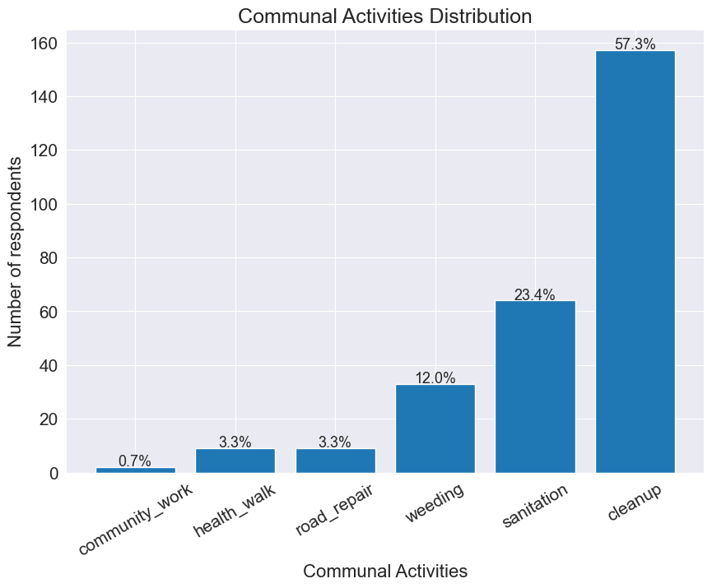

Figure : Communal Activities

Almost 70% of the respondents showed an interest in joining future youth activities. These activities may range from open discussions about governance to seminars and workshops organized for the youth. Despite considerable number of respondents showing interests, approximately 16% expressed no interest in taking part in such activities while 14% were not sure of their stance.

**Needs and Interests**

One of the most important reasons for conducting this survey was to inquire about the challenges the youth face in their various communities. Unanimously, all the electoral areas had considerable challenges with employment. Other pertinent challenges such as drug and alcohol abuse were noticeable although several respondents claimed this was directly caused by unemployment. A more elaborate presentation of the challenges is given in Figure 9. Despite some common challenges, each electoral area had their own unique challenges expressed by the respondents. Plots of the challenges faced by each electoral area can be found in the Appendix section of this report.

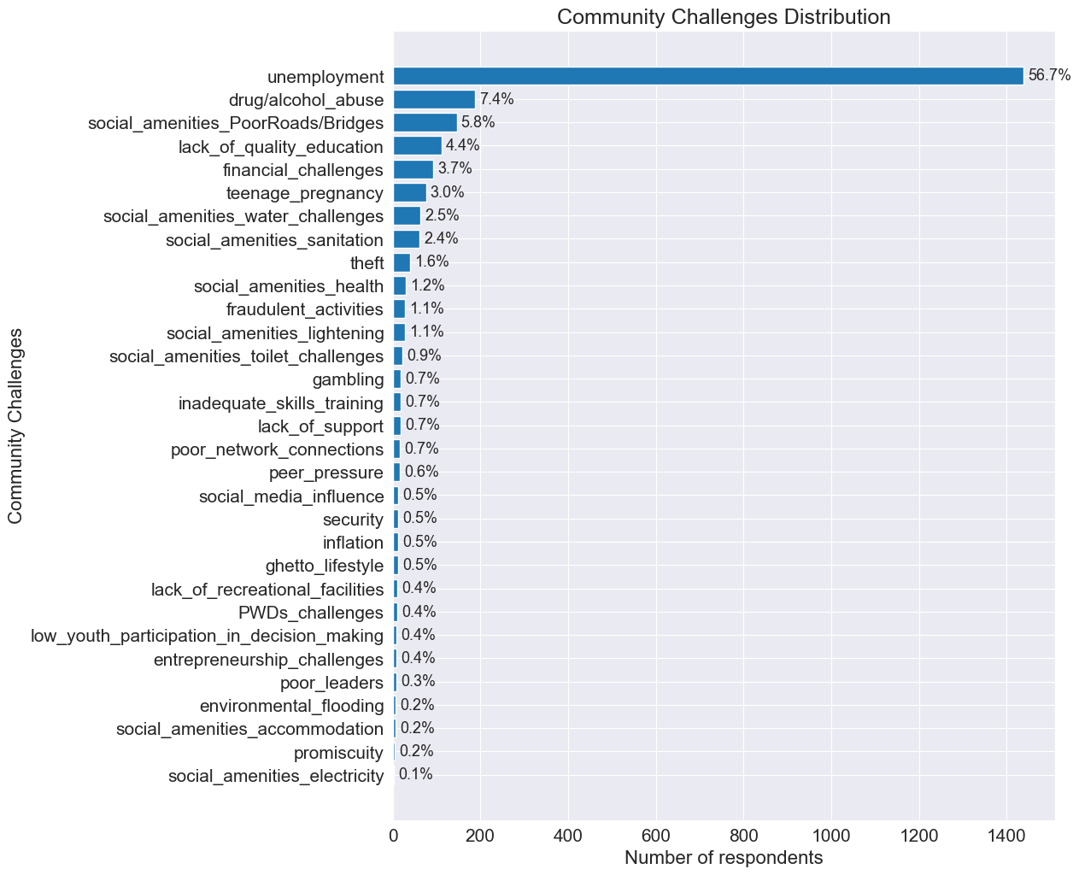

Figure : Challenges facing the youth.

Figure 10 throws more light into the interests of the youth in the NJSM. It is obvious from Figure 10 that most of the youth are interested in movies, games and sports. In the case of sports, since it also acts as a way of exercising and keeping the body fit, more attention is needed in this area. It might be of great importance to create more recreational facilities and promote more sporting activities. Also, given that movies take lead, creation of cinemas and other such ventures might go a long way to meet the interests of the youth.

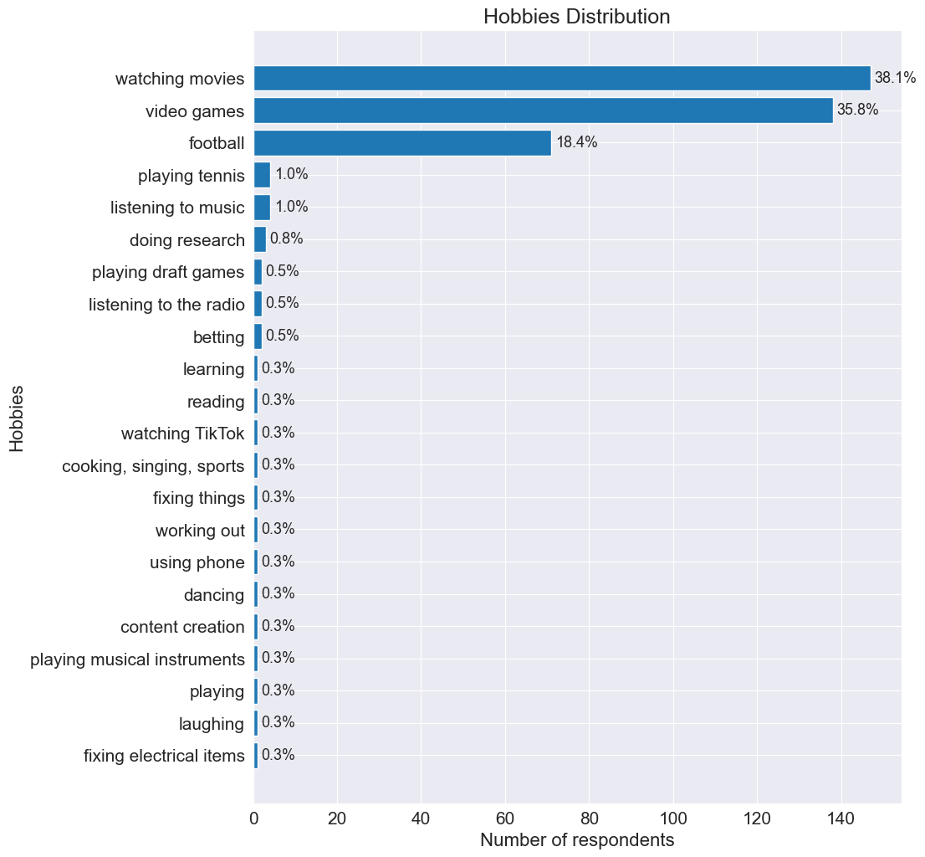

Figure : Hobbies and Interest

**DISCUSSIONS**

We have more respondents between the ages of 21 – 25 who have attended school in the past, the most dominant level being the SHS followed by Tertiary and JHS. Only a small number attended TVET in the past. A similar observation can be made across all age groups (as seen in Figure 11).

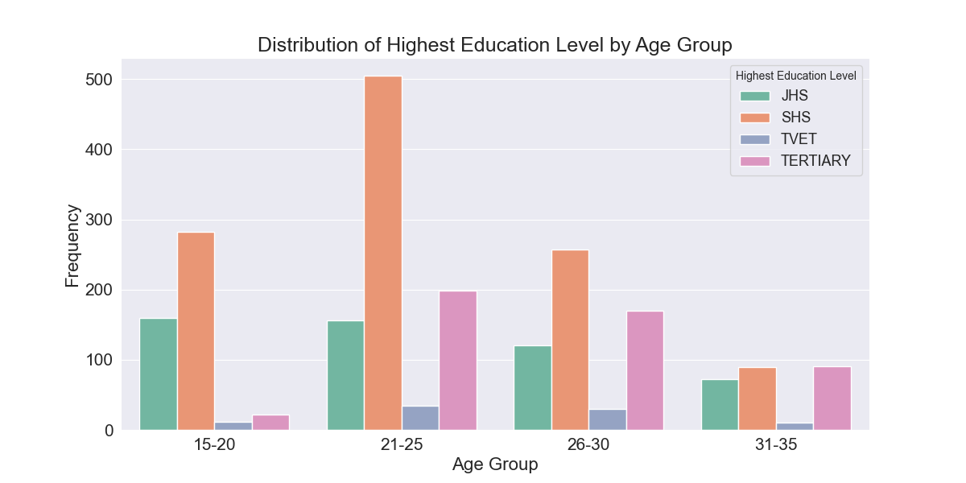

Figure : Highest education level across age groups.

This emphasizes the lack of interest in the youth in attending TVET institutions. In part, this could be attributed to the perception and general demeaner given to TVET institutions. The role of TVET is of vital importance to the youth as it equips the youth with immediately employable skills. This indicates that a considerable effort must be taken to ensure that the TVET sector is lucrative enough to attract the youth because as more youth gain highly employable skills, the burden of unemployment can be reduced. Again, most students in TVET institutions may end up creating their own jobs thereby becoming entrepreneurs themselves. On other hand, most of the respondents who are currently schooling fall between the ages of 15 – 20. Out of this, a significant proportion are enrolled in the SHS. A more detailed information about this distribution is given in Figure 12.

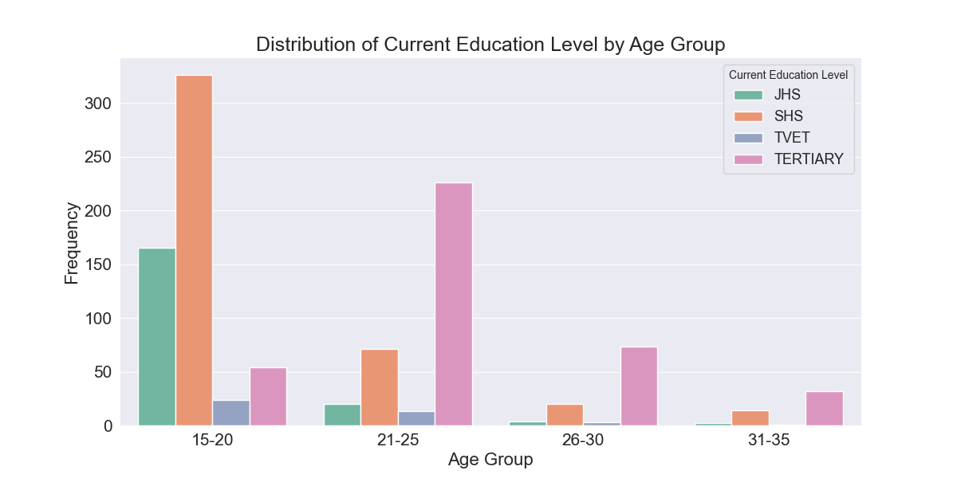

Figure : Current educational level across age groups.

One observation that is very important is to check the employment status across the different age groups to determine the actual unemployment rate. From Figure 13, it is obvious that most of the unemployed respondents are between the ages of 15 – 20. With this age range, most individuals are expected to be in schools and not working, hence the higher number of unemployment. For the age groups 21 – 25 and 26 – 30, they are expected to have entered the workforce (except a few who may be in tertiary). That is, these actually confirms the problem of unemployment as already established Figure 9.

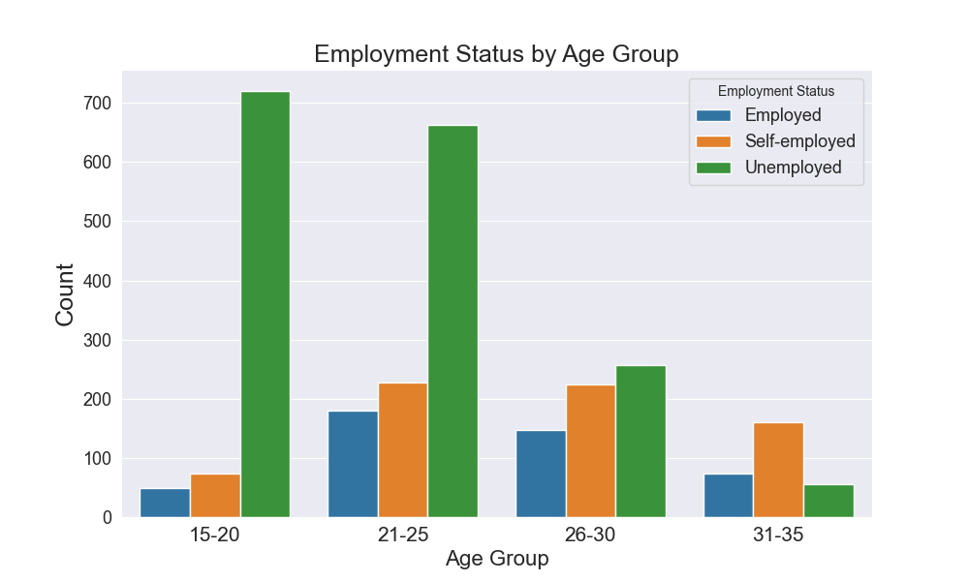

Figure : Employment status across different age groups.

Regarding the issue of unemployment, one question that always arises is “how education affects the employment status of individuals.” As we can see in Figure 14, we have that most of the unemployed respondents have attended school in the past. This could hint to several issue;

Firstly, there is a general consensus that whatever is taught in school does not directly apply in the job market, hence most graduates with lack of any actual job experience find it extremely difficult to enter the workforce, hence the huge number of unemployed graduates. This could be remedied by establishing relevant relationships between schools and industries such that by the time a student graduates from school (even at the SHS level), they would have attained some hands-on experience in the field of specialization. This could go a long way to bridge the gap between academia and the industry, ultimately reducing the rate of unemployment.

Secondly, this observation could be as a result of more qualified individuals competing for very few job openings. In this case, the obvious solution would be the creation of more employment opportunities.

Another interesting observation that can be made from Figure 14, is the small number of unemployed youths who have never been to school. This is because only small proportion of the youth have never been to school. Out of that small number, most engage in trading and learning of various skills such as braiding, barbering, sewing, etc at an early age and hence work as apprentice to others or even create their own shops.

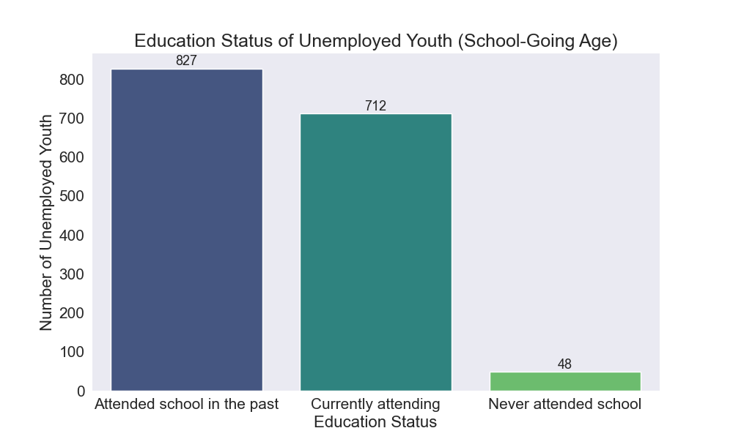

Figure : Education status of unemployed youth.

For persons with disabilities (PWD), a significant number of them are unemployed (illustrated in Figure 15). This should be of great concern because most of these individuals lack reasonable accommodations to effectively contribute to the society as a whole. There is also the problem of perception, where most employers shy away from employing persons with disabilities simply because of their deformities or because they generally lack information on how to deal with such persons and to avoid any problems, they simply do not hire persons with disabilities. Although PWDs form small percentage of the entire population, their needs and challenges must be of utmost importance so as to create an inclusive society. To address these issues, the most immediate and perhaps obvious remedy would be to create awareness and sensitize the general population on issues regarding persons with disabilities. This could range from constitutional laws that support their rights to provision of reasonable accommodations by employers. Again, there should be the enforcement of laws such that individuals would not be denied employment opportunities they qualify on the grounds of their disability. Most importantly, there could creation of skills and training workshops and entrepreneurship classes specially designed for PWDs to equip them with the skills, knowledge and possibly the resources to set up their own businesses. This in turn will reduce the burden of unemployment on the government.

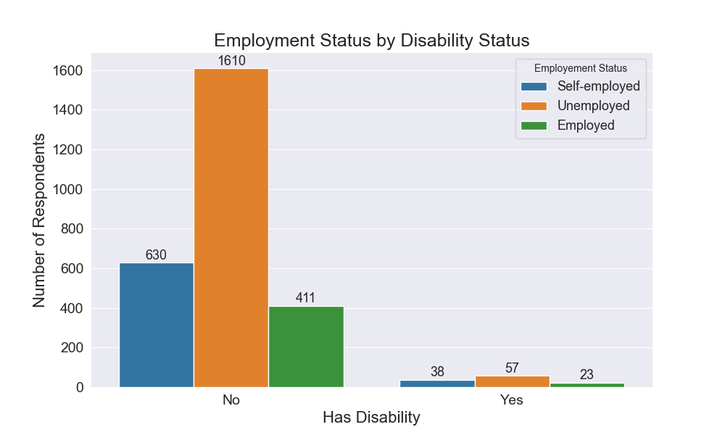

Figure : Employment by disability status

As illustrated in Figure 16, we have that approximately 59% of all male respondents are unemployed compared to about 62% unemployed females. This generally asserts that unemployment is greater in females than in males. The percentage of self-employed respondents is similar for both genders with about 24%. The itching question will be the cause of different unemployment rates between males and females.

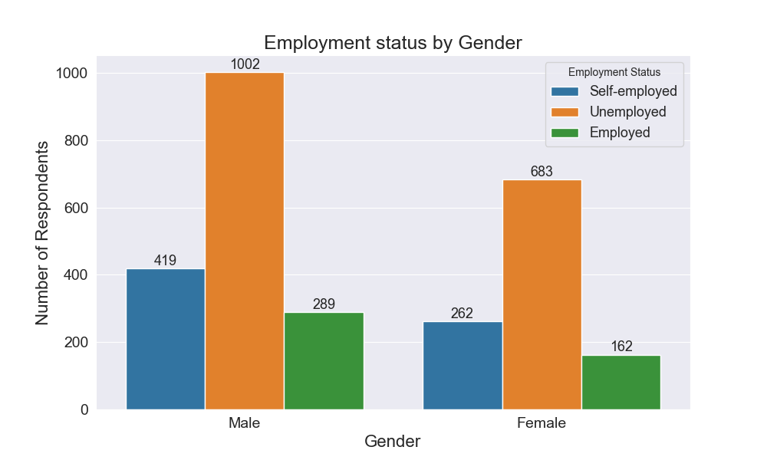

Figure : Employment by gender

Now, concerning the civic participation of the youth, Figure 17 shows the number of respondents who plan to vote in the upcoming election given their participation in town hall meetings. Despite the rather small number of participants that have taken part in town hall meetings, about 76% said they would be voting in the upcoming elections compared to the 47% for those who had never taken part in town hall meetings and the 68% who were not sure of their participation in town hall meetings. Based on this result, it suffices to conclude that youth participation in town hall meetings encourages or enlighten them on the importance of exercising the civic rights.

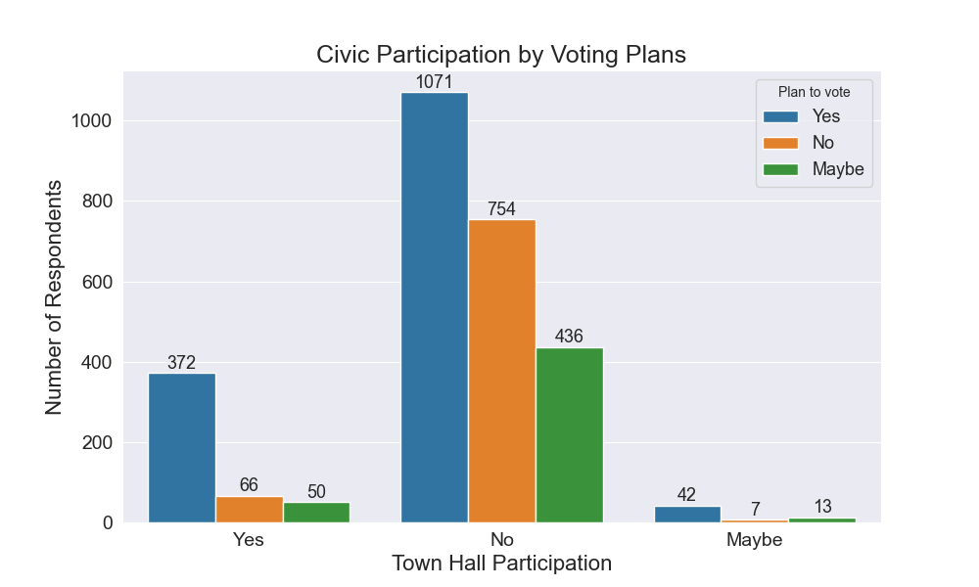

Figure : Voting plans by civic participation.

Among all age groups, a larger proportion were enthusiastic about keeping in touch with youth organisations that promote youth activities and participation as illustrated in Figure 18.

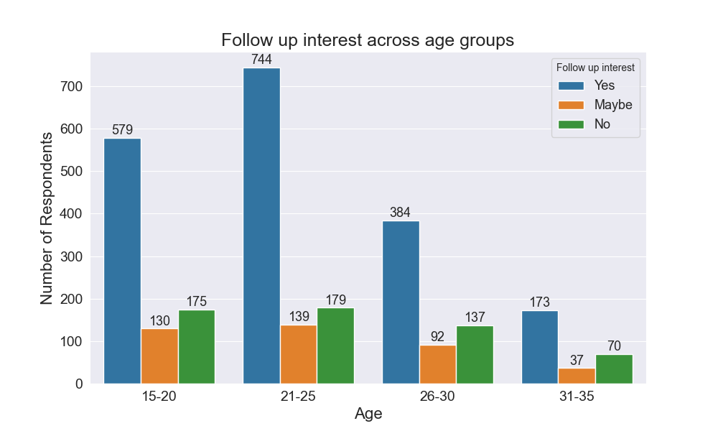

Figure : Interest in keeping in touch with youth groups across different ages.

Given the participation of respondents in communal activities and their corresponding educational levels, generally, there seem to be a higher participation rate across all educational levels (as shown in Figure 19), although the rate of participation of respondents who are currently school and those who have attended school in the past are relatively higher compared to those who have never been to school (76% and 70% participation rates respectively). This observation could in part be attributed to the fact that those who have had some form of formal education may be privy to information on the benefits of engaging in such activities.

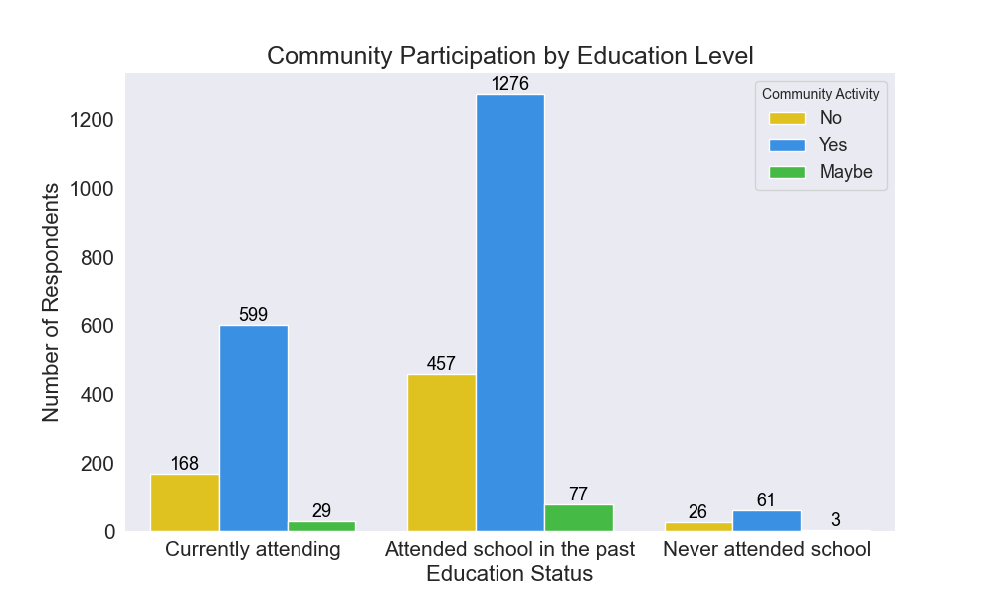

Figure : Community participation by education level.

Comparing the respondents’ participation in communal activities by their employment status, we observe a general positive response towards participation. However, the participation rate of unemployed respondents is relatively higher compared to employed and self-employed respondents (shown in Figure 20).

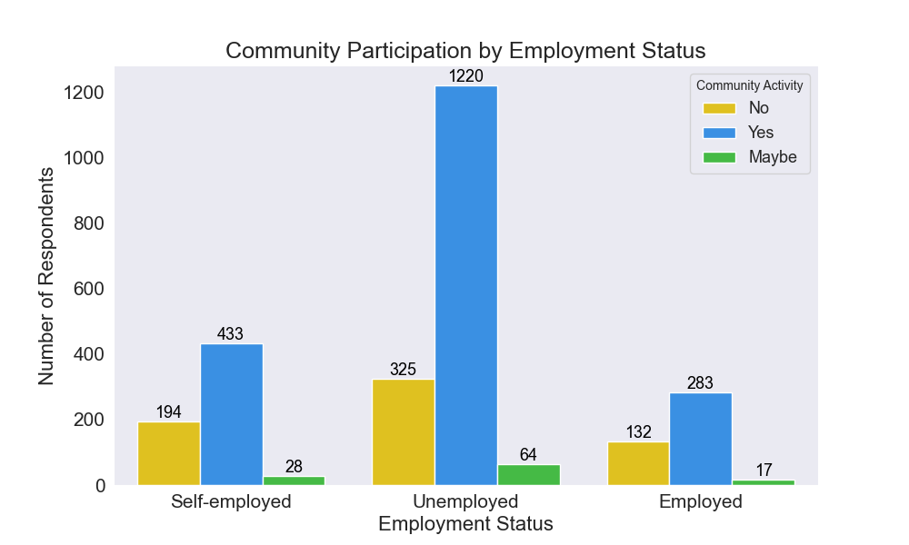

Figure : Community participation by employment status

This could be attributed to the continuous availability of most of the unemployed youths in the community as most of the working population might probably be in their respective places of work during the time such activities might take place.

To know more about the employment status of the respondents in the various electoral areas, we have made a plot of the employment status by residence, which is shown in Figure A34 to A36.

**CONCLUSION**

**APPENDIX**

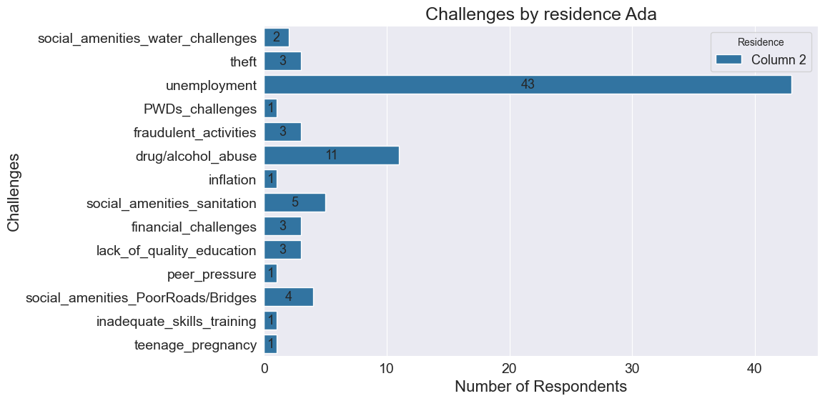

A : Challenges in Ada

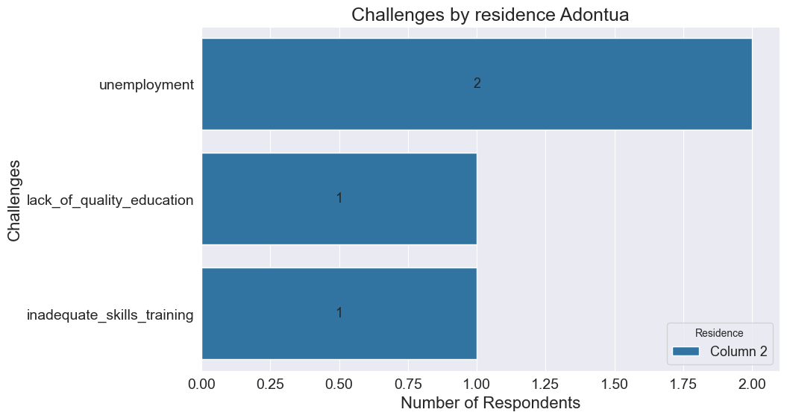

A : Challenges in Adontua

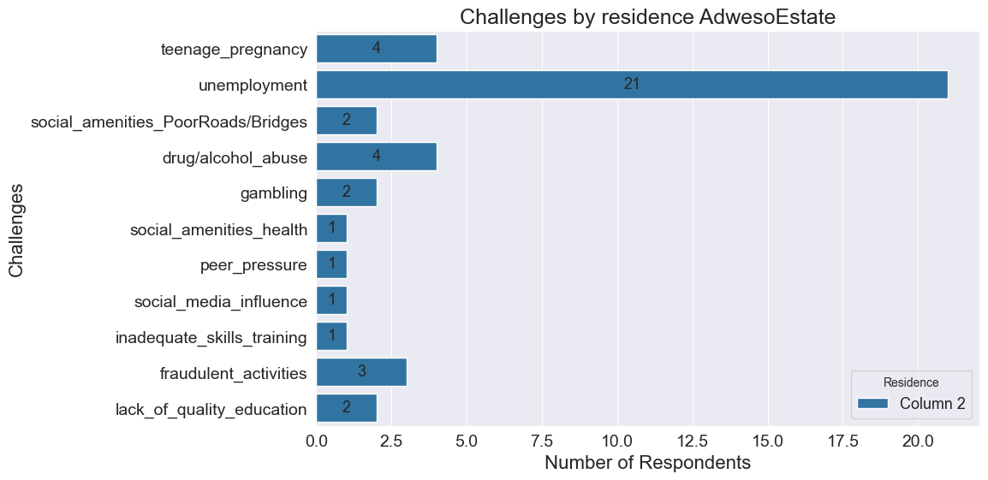

A : Challenges in Adweso Estate

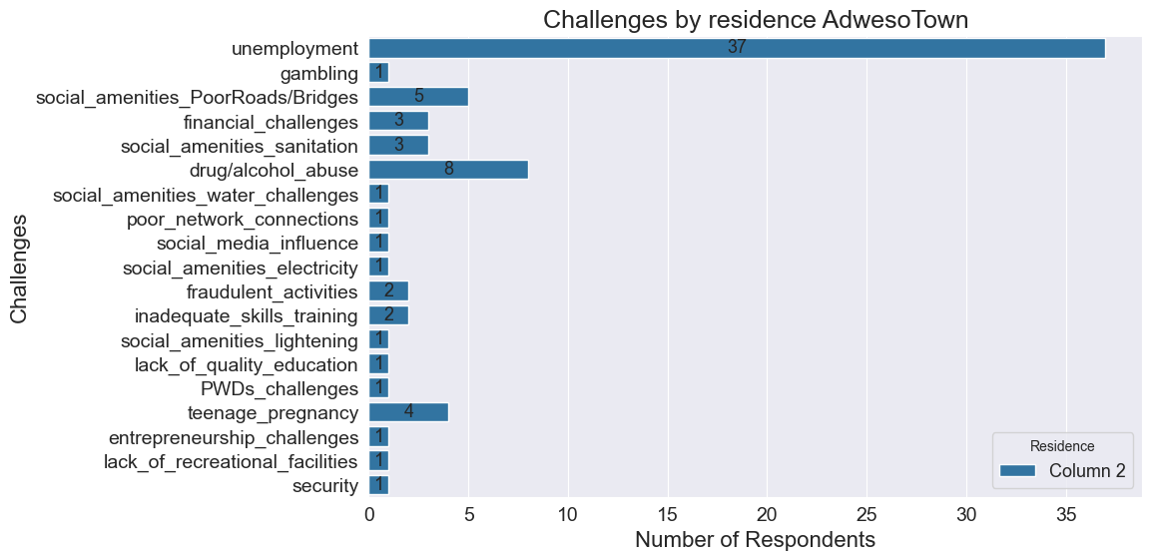

A : Challenges in Adweso Town

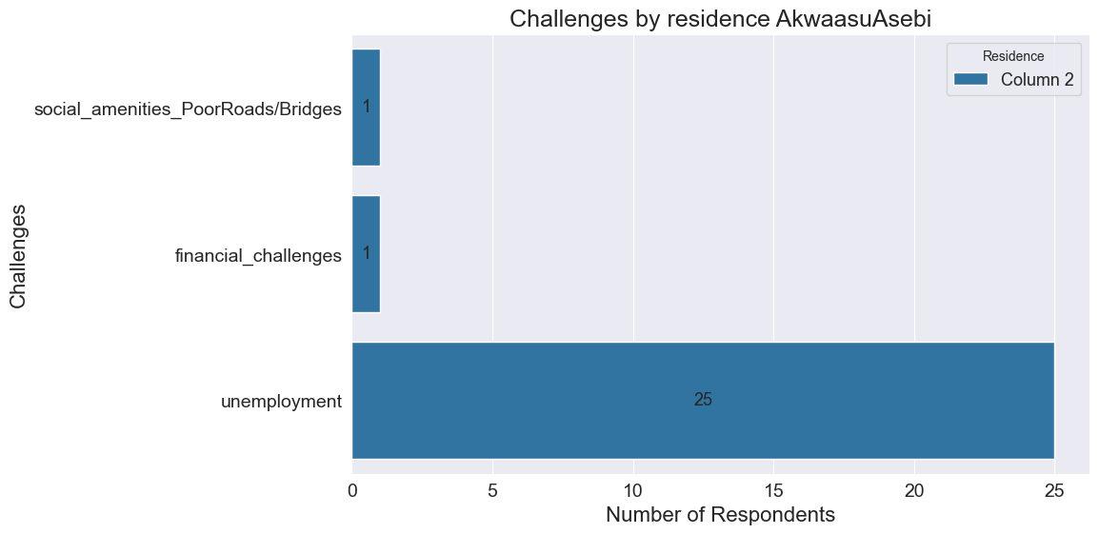

A : Challenges in Akwaasu Asebi

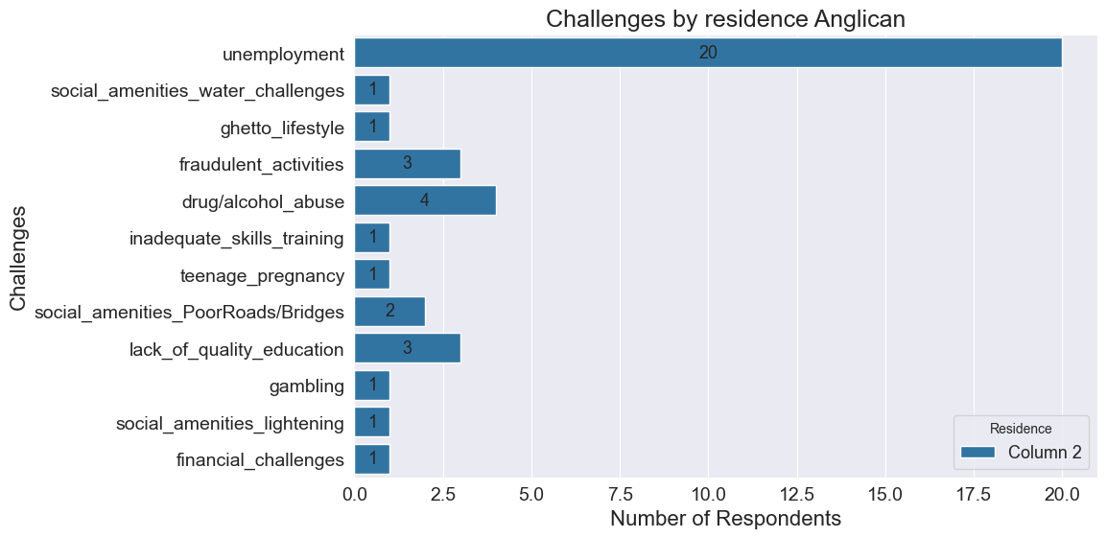

A : Challenges in Anglican

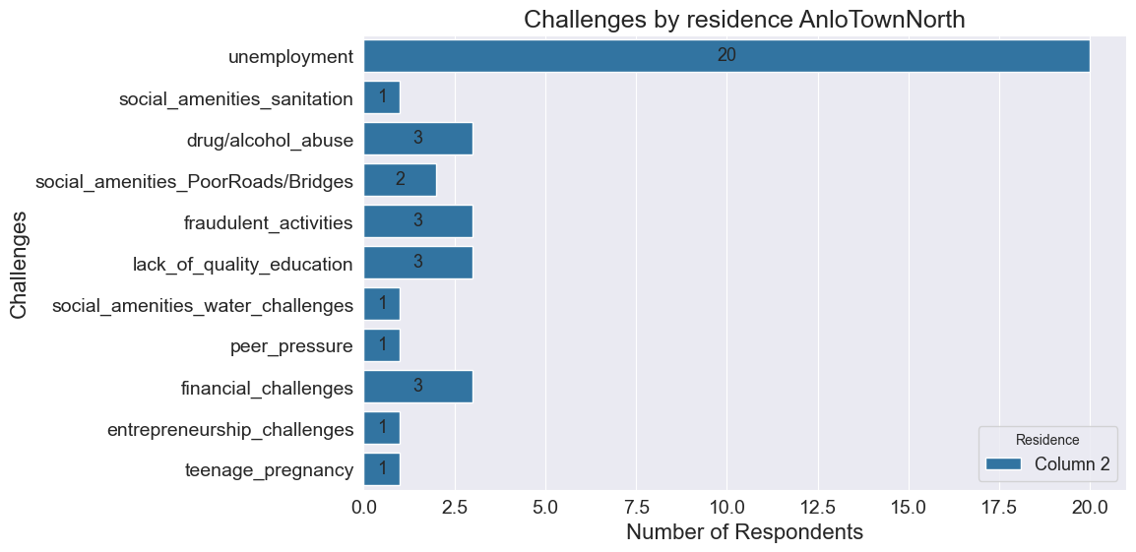

A : Challenges in Anlo Town North

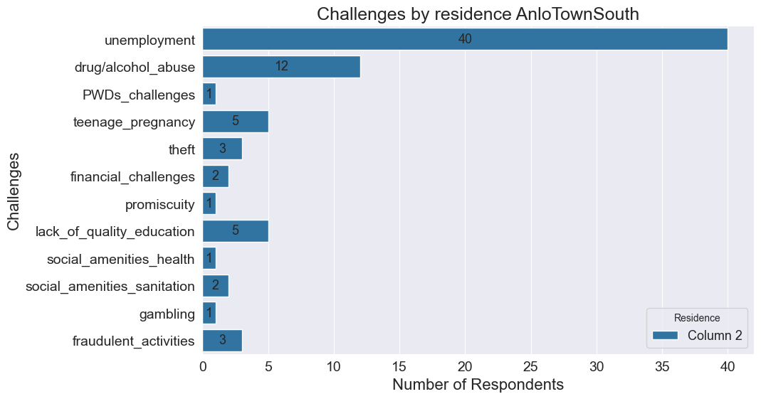

A : Challenges in Anlo Town South

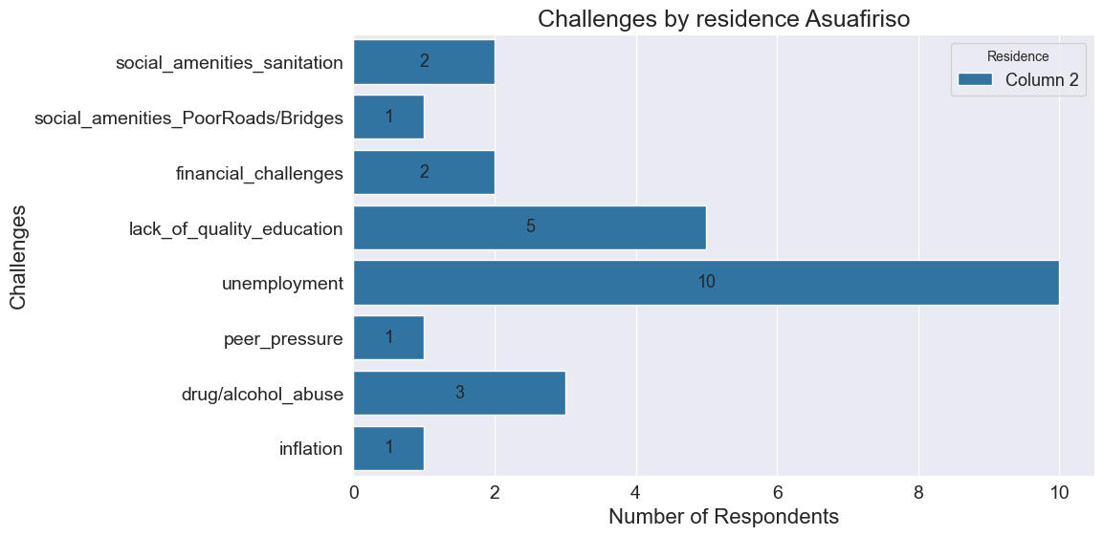

A : Challenges in Asuofiriso

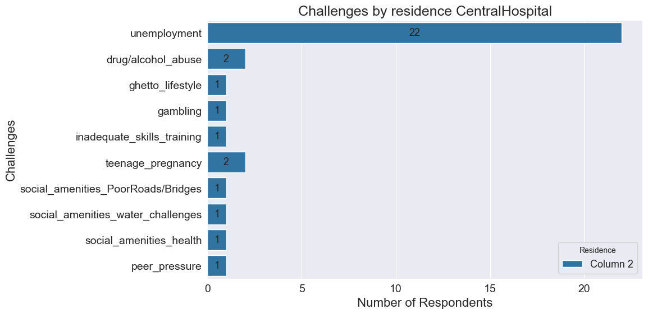

A : Challenges in Central Hospital

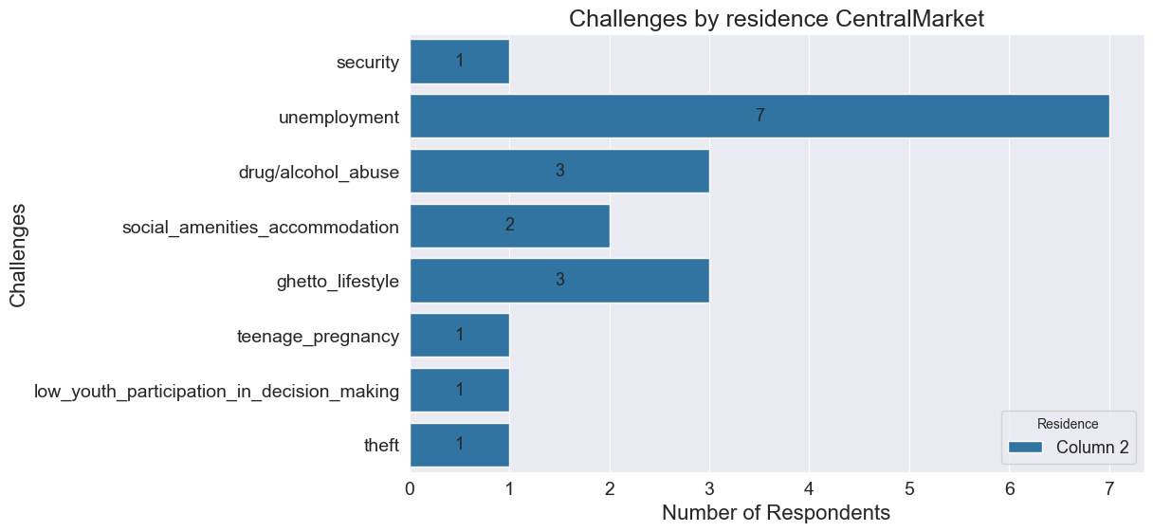

A : Challenges in Central Market

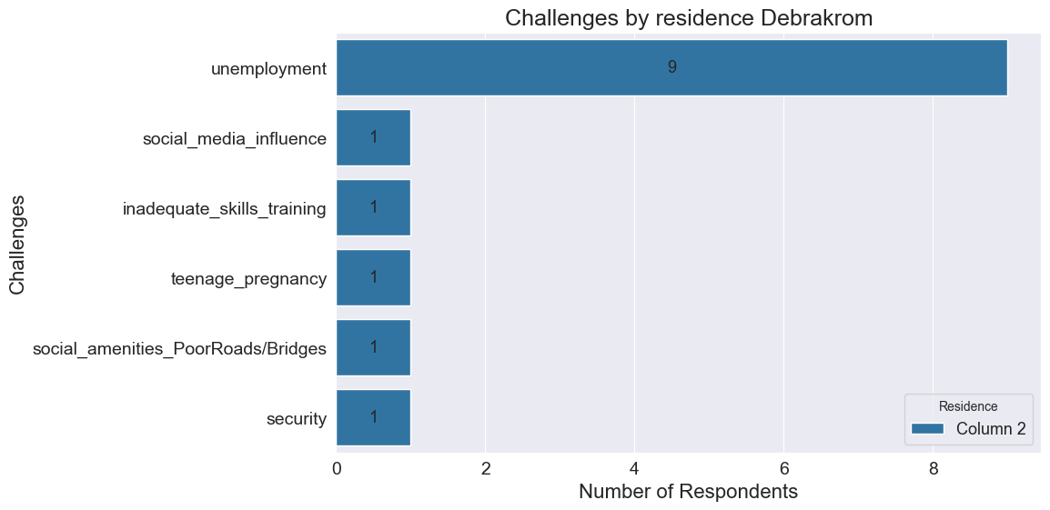

A : Challenges in Debrakrom

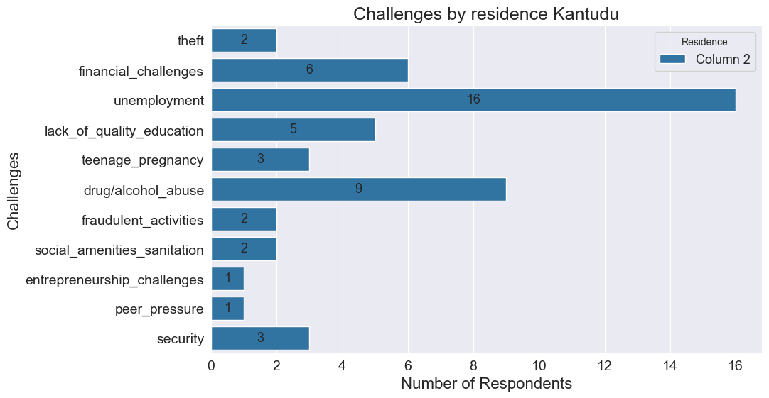

A : Challenges in Kantudu

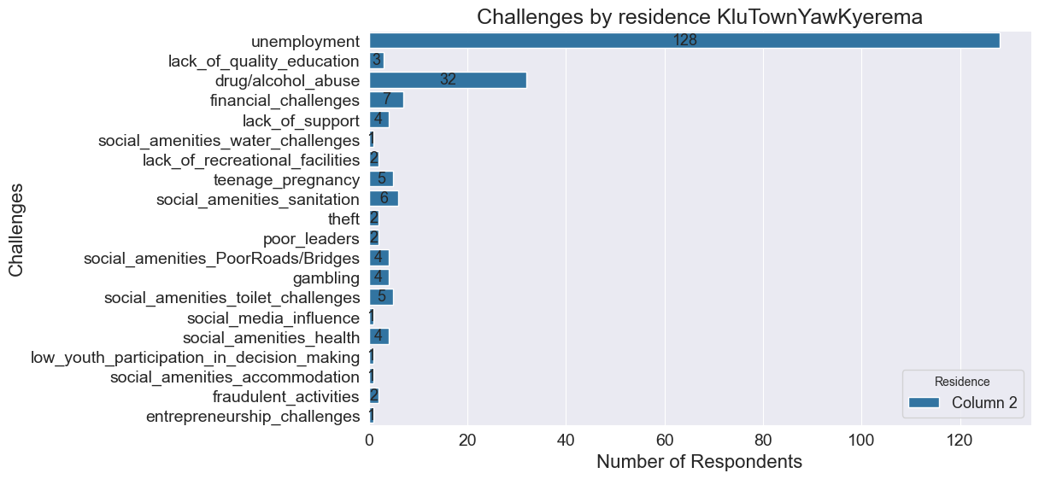

A : Challenges in Klu Town Yaw Kyerema

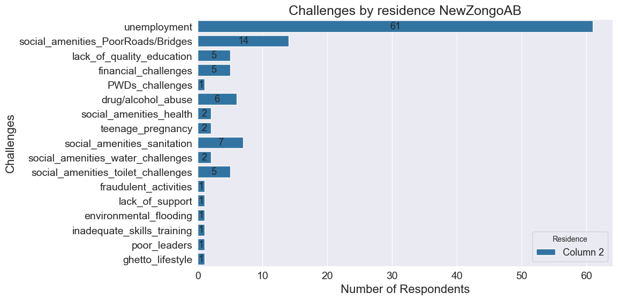

A : Challenges in New Zongo AB

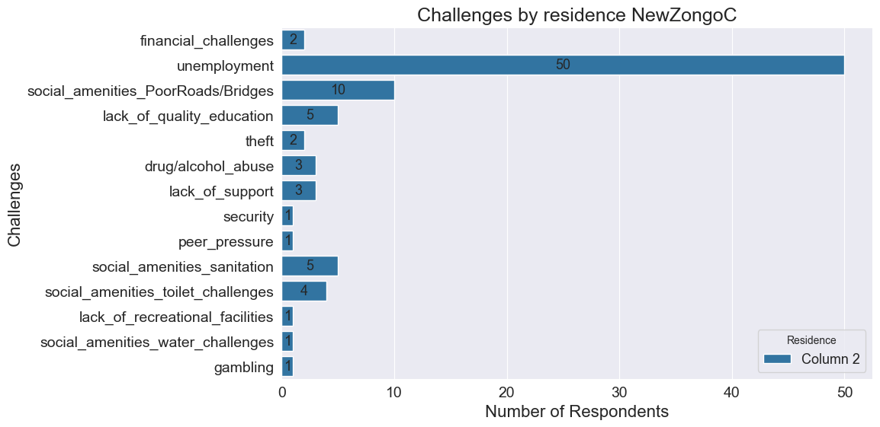

A : Challenges in New Zongo C

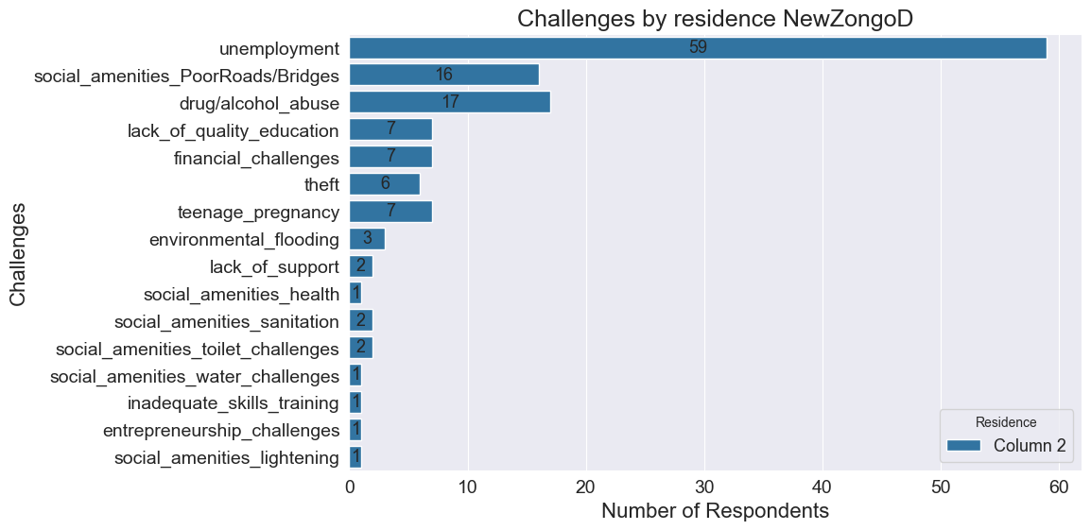

A : Challenges in New Zongo D

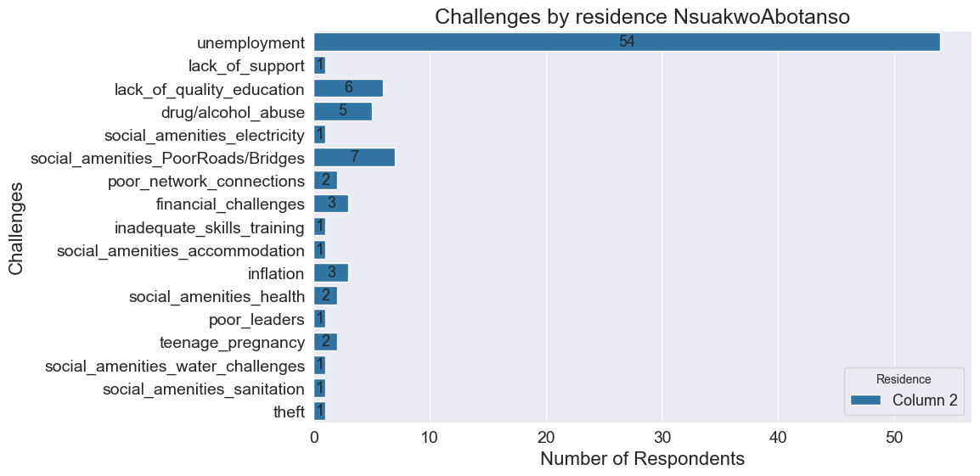

A : Challenges in Nsukwao Abotanso

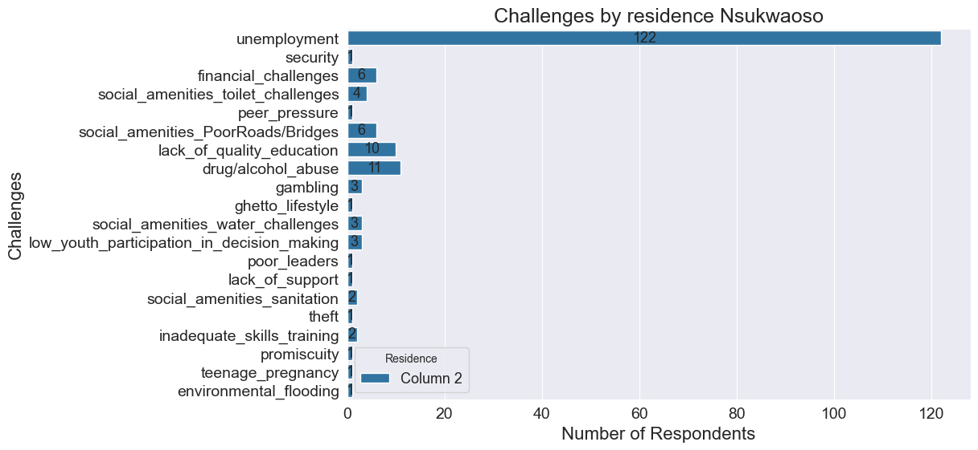

A : Challenges in Nsukwaoso

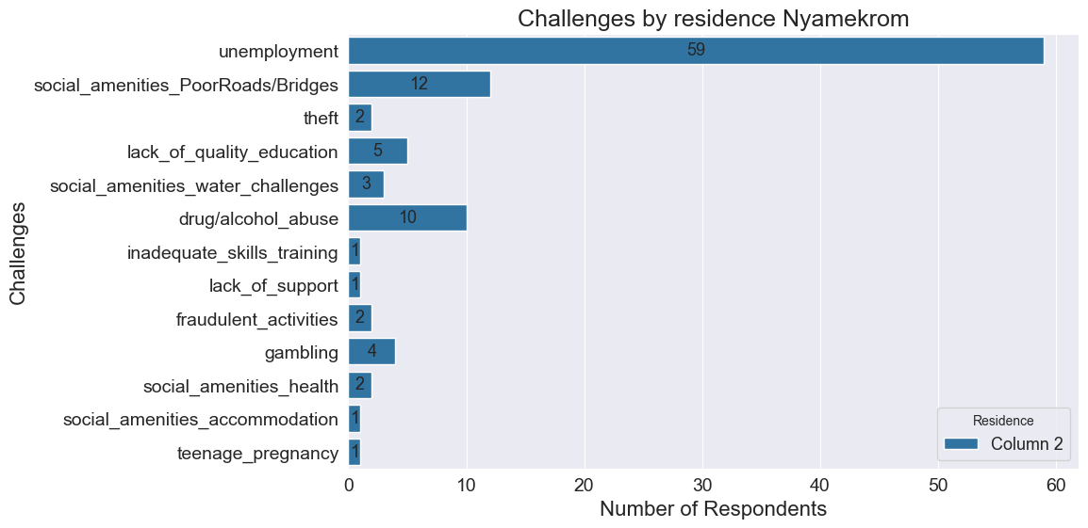

A : Challenges in Nyamekrom

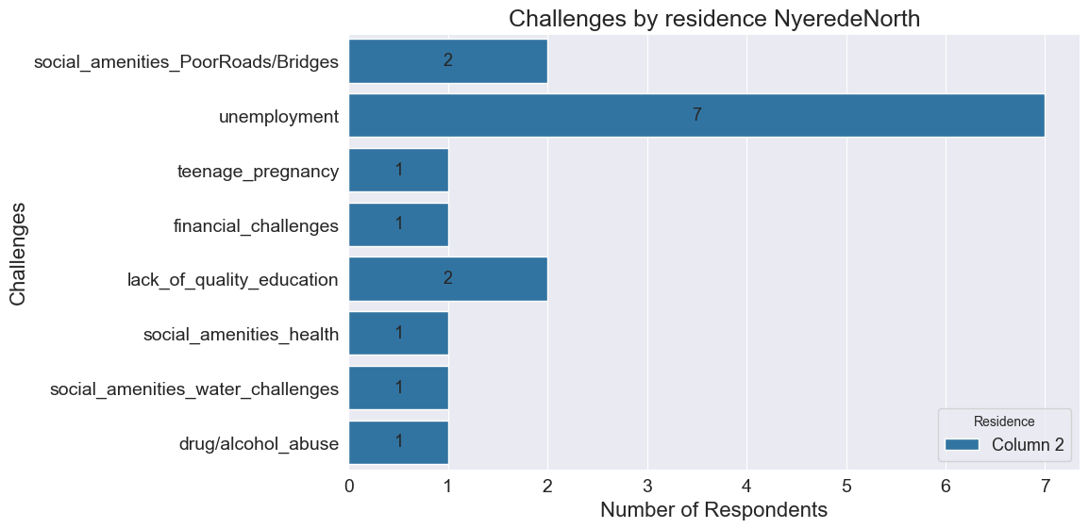

A : Challenges in Nyerede North

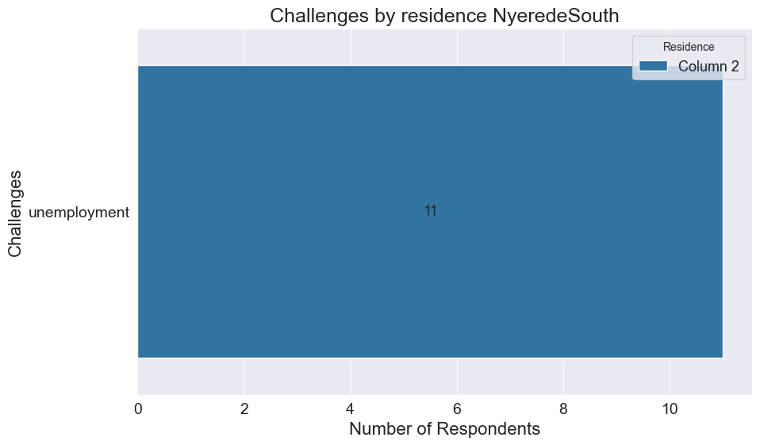

A : Challenges in Nyerede South

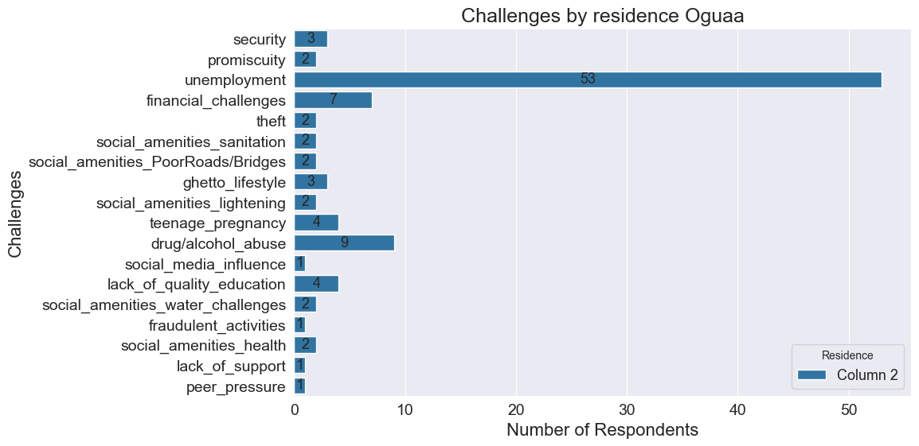

A : Challenges in Oguaa

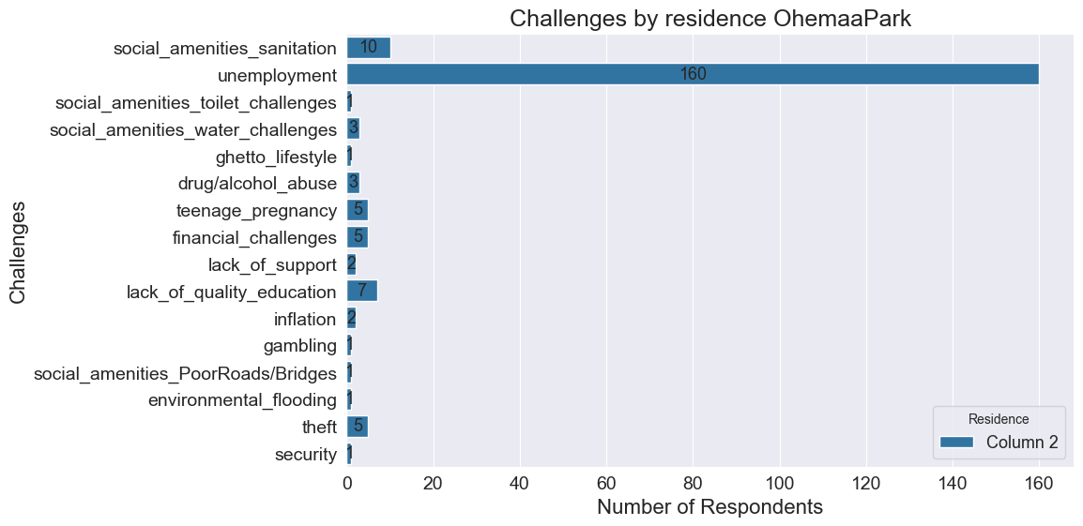

A : Challenges in Ohemaa Park

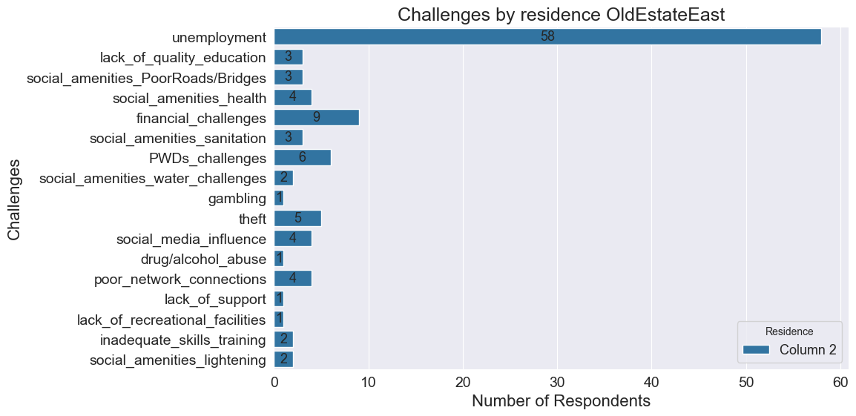

A : Challenges in Old Estate East

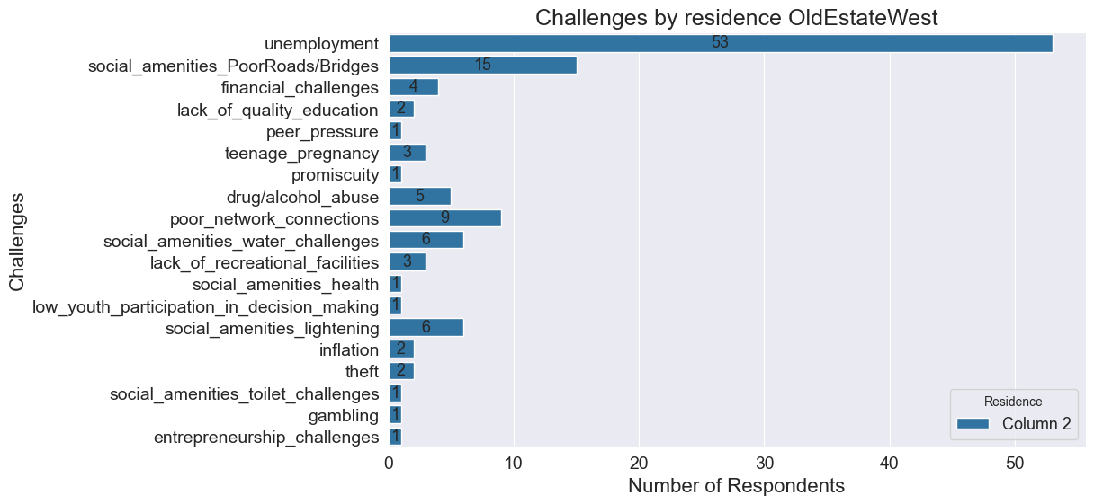

A : Challenges in Old Estate West

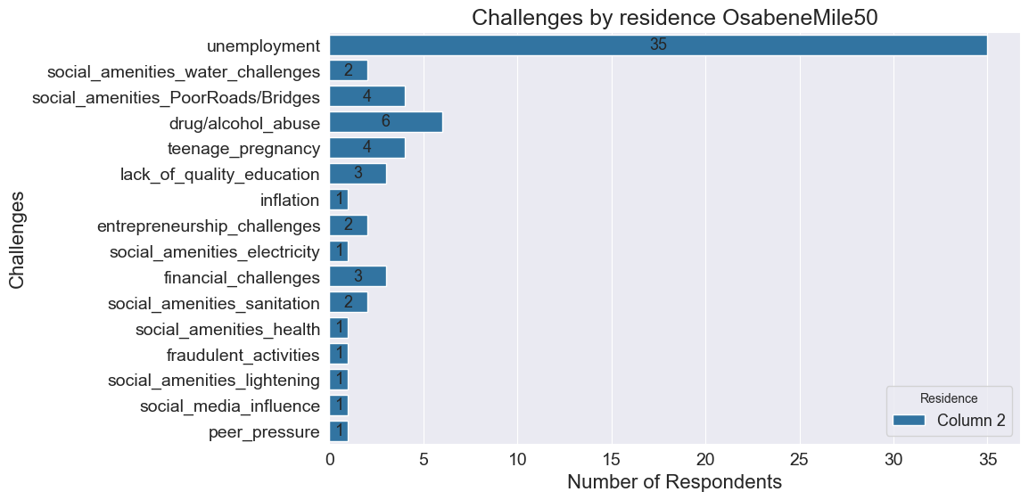

A : Challenges in Osabene Mile 50

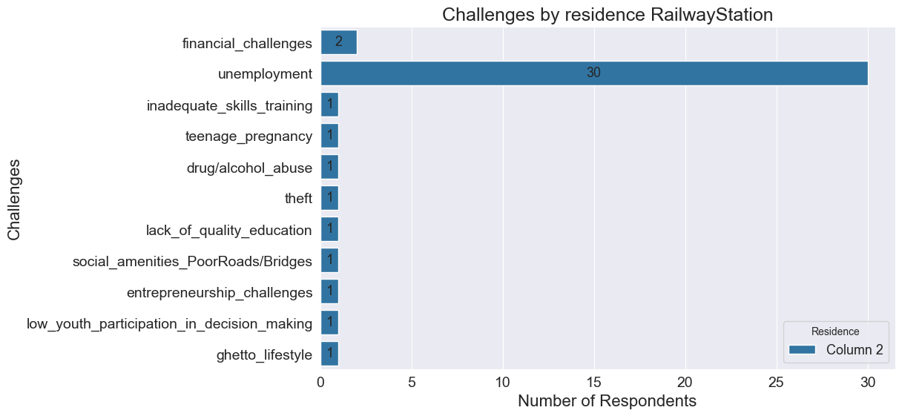

A : Challenges in Railway Station

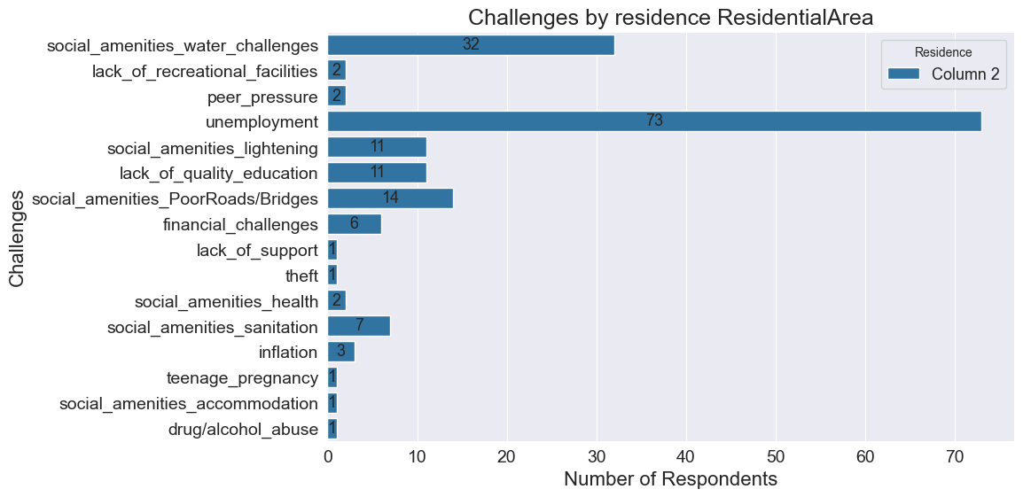

A : Challenges in Residential Area

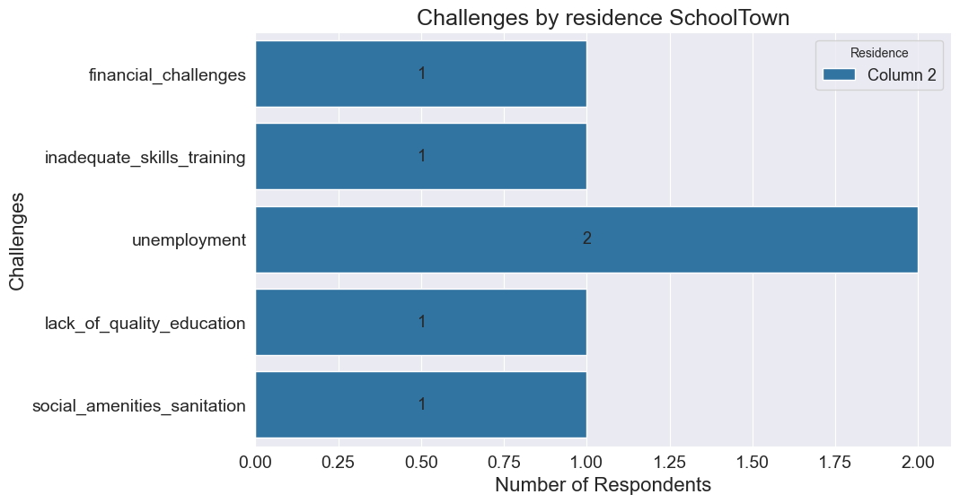

A : Challenges in School Town

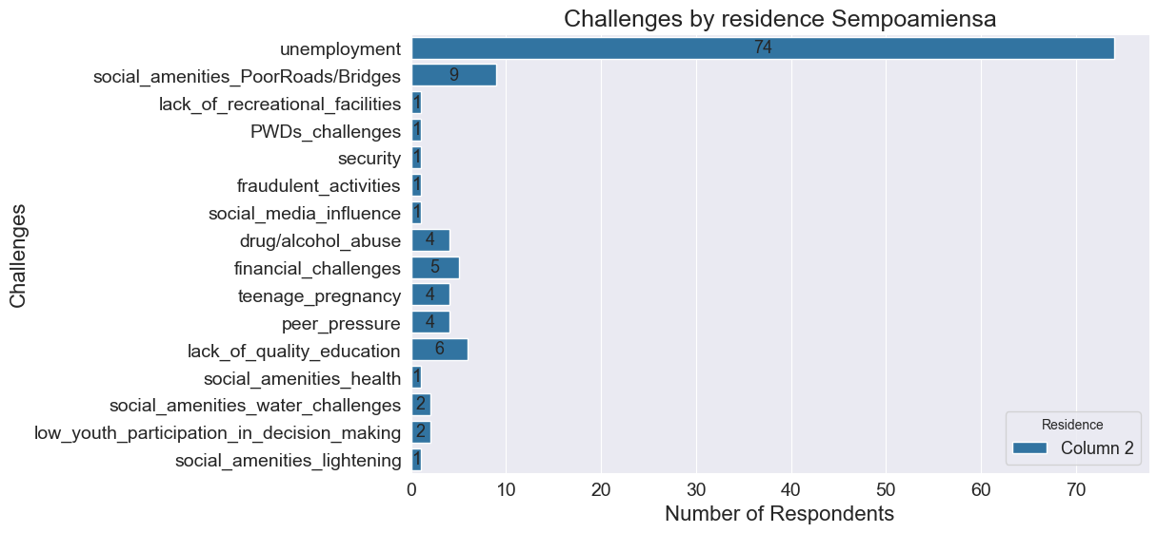

A : Challenges in Sempoamiensa

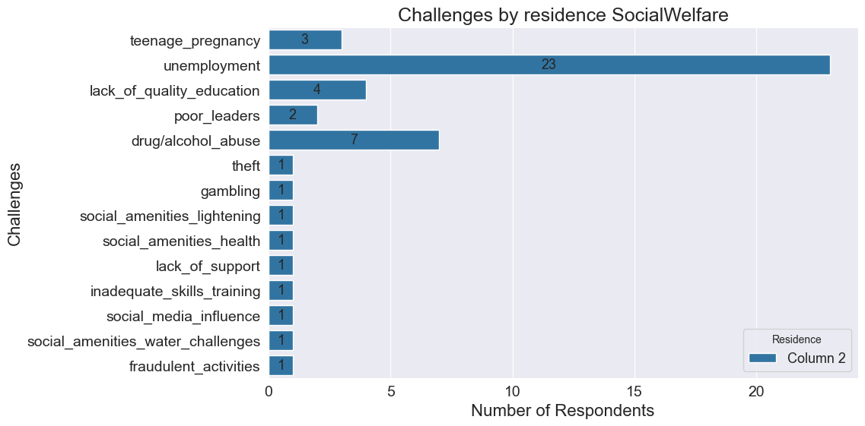

A : Challenges in Social Welfare

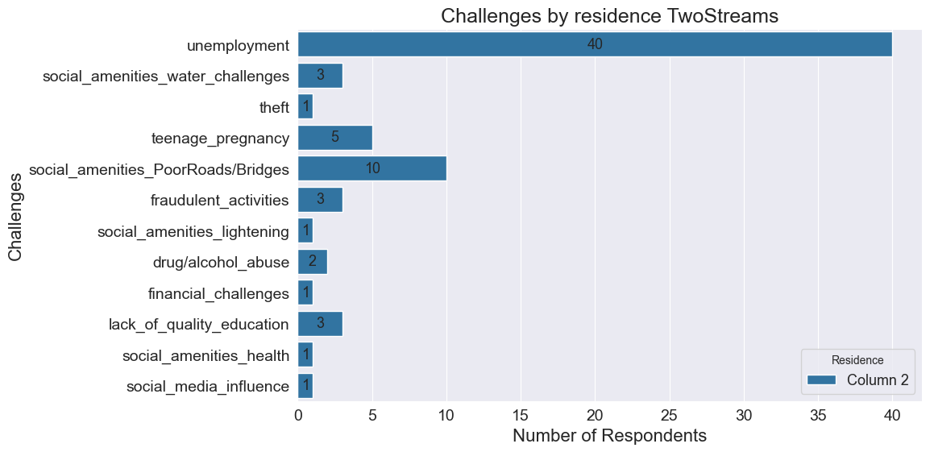

A : Challenges in Two Streams

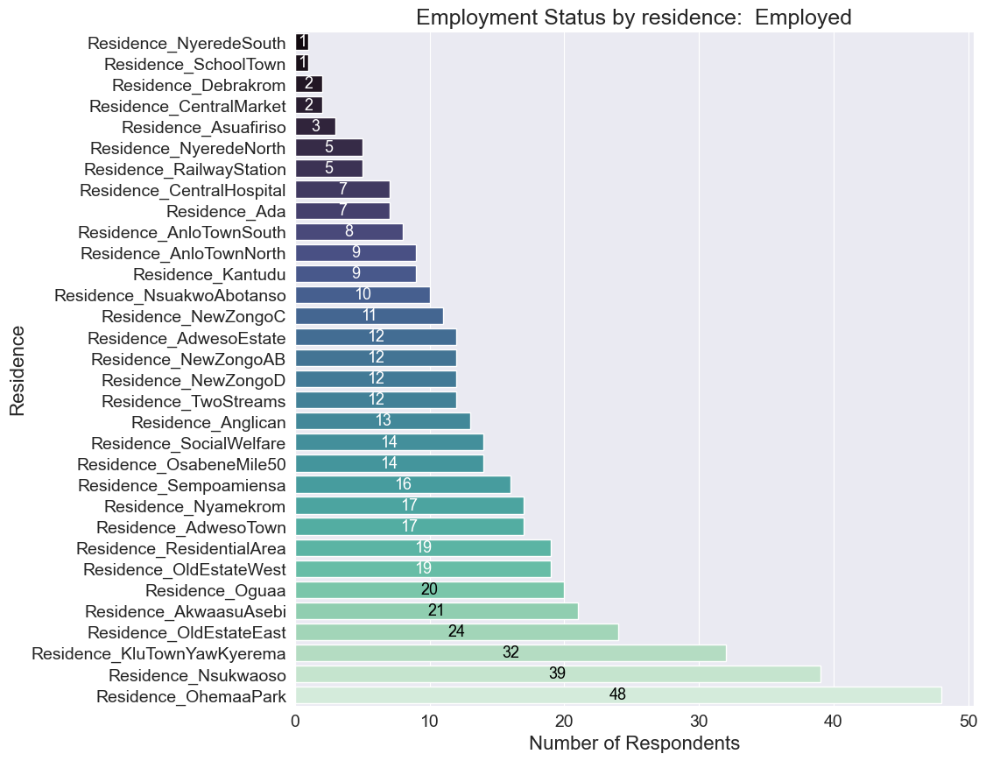

A : Employed individuals in each electoral area

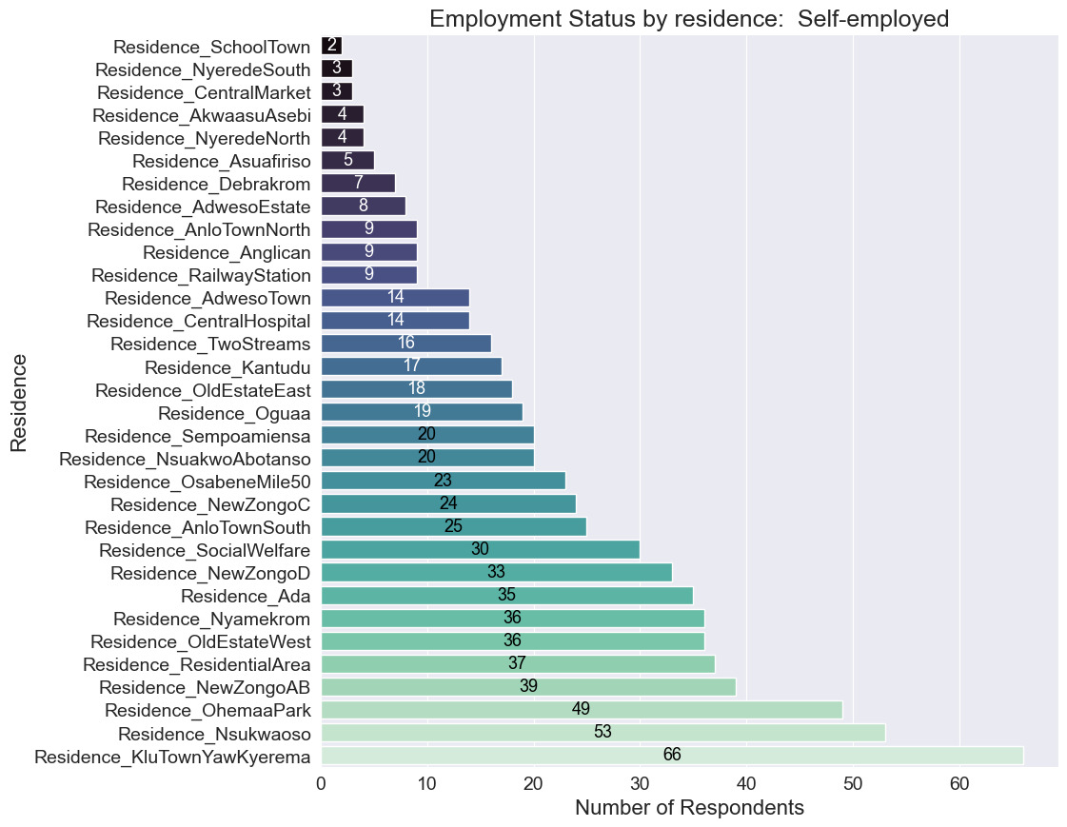

A : Self-employed individuals in each electoral area

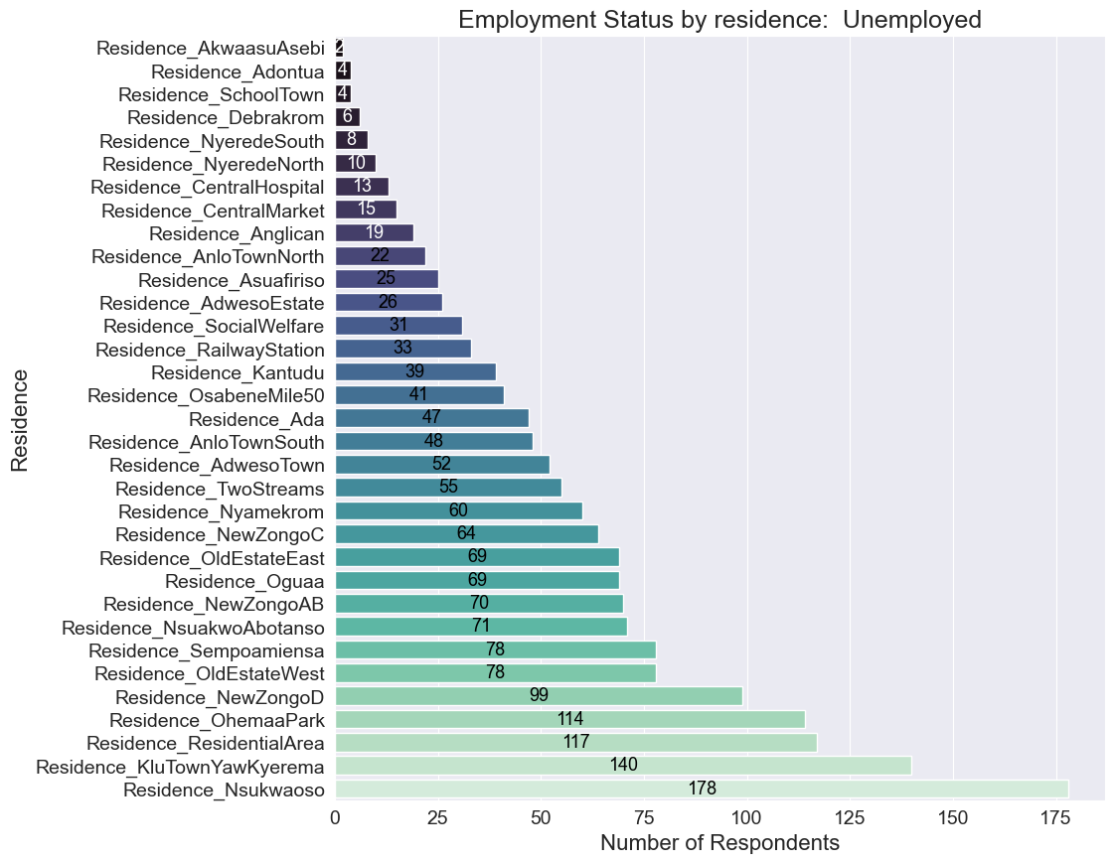

A : Unemployed individuals in each electoral area